|  |  |
| --- | --- |
| cetlogo ***CHEMICAL ENGINEERING TRANSACTIONS***  ***VOL. , 2024*** | A publication of  aidiclogo_grande |
| The Italian Association  of Chemical Engineering  Online at www.cetjournal.it |
| Guest Editors: Leonardo Tognotti, Rubens Maciel Filho, Viatcheslav Kafarov  Copyright © 2024, AIDIC Servizi S.r.l. **ISBN** 979-12-81206-09-0; **ISSN** 2283-9216 | |

Torrefaction of wood pellets in Uruguay: Effect in the energy properties

Laidy E. Hernandez-Menaa,\*, Ezequiel Garciaa, Isora Fernandeza, Yessica L. Pereiraa, Waldir A. Bizzob

a Centro Universitario Regional Noreste, Universidad de la República, Route 5, km 386, Tacuarembó, Uruguay

bUniversidade Estadual de Campinas (UNICAMP), Faculdade de Engenharia Mecanica, 13083–860 Campinas, SP, Brazil

laidy.hernandez@cut.edu.uy

The objective of this work was to study the process of torrefaction of pellets produced from pine residues generated in the sawmill process in Uruguay. The pellets were torrefied in a tubular furnace at a heating rate of 5 °C/min under an inert atmosphere. The experimental torrefaction tests were carried out at temperatures of 250 and 300 °C and holding times of 30 and 60 min. The performance of the process was evaluated in terms of mass yield, energy yield, and torrefaction factor. The raw and torrefied pellets were evaluated for thermal, physical, and chemical characterization. The effect of the torrefaction process on the pellet quality was studied. In addition, the combustion behavior of the raw and torrefied pellets was analyzed using thermogravimetric analysis (TG-DTG) and differential scanning calorimetry (DSC). The increase in temperature reduces the mass yield of the torrefied pellets while increasing the HHV, carbon content, and ash content. Incorporating torrefaction and pelletizing processes improves the energy properties of pellets, other research is required to evaluate the costs associated with handling, transportation, and storage for power generation applications.

* 1. Introduction

The increase in the consumption of fuels sourced from renewable energies in Uruguay has reshaped demand across residential, commercial, and industrial sectors. Biomass, as a renewable resource, not only mitigates greenhouse gas emissions but also facilitates the production of biofuels for transportation, electricity, and heat through direct combustion or conversion processes (Tursi, 2019). This versatile source can be stored and used to generate energy on demand, contributing to regional and global energy supplies (Rentizelas et al.,2009). Biomass in Uruguay covers 40% of the country's primary matrix, with 75.5% coming from waste (black liquor, wood chips, sawdust, rice husks, sugar cane bagasse, pellets and briquettes, and others), 21% from firewood, and 3.5% from biofuel (BEN,2022). The advances in the forestry sector have encouraged the search for new sustainable alternatives for the management of woody biomass, especially wastes from the wood processing industry (shavings, sawdust, chips, bark) generated by small and medium enterprises, whose destination is still undefined and which can complement the national energy matrix. The cost of the supply chain and the technology required to convert biomass into useful forms of energy are some of the most significant barriers to the increased use of biomass in the energy supply. Biomass has low density, high moisture content, and low calorific value, and requires investment in equipment for collection, handling, transportation, and storage (Rentizelas et al.,2009).

In recent years, pretreatment technologies like densification and torrefaction have developed for waste biomass applications, to improve the fuel properties of solid biomass. Densification is a process that uses mechanical force to compress previously ground biomass waste into pellets or briquettes. The benefits of densified biomass include lower moisture content, increased volumetric energy density and energy efficiency, reduced emissions, and improved combustion control (San Miguel et al., 2022). Pelletizing results in the formation of a solid fuel with a regular size and shape suitable for residential heating applications and commercial power generation, including combustion and gasification. Pelletizing of sawdust increases its bulk density from 100-200 kg/m3 to 550-750 kg/m3, which is the main factor in reducing transportation, handling, and storage costs (Kumar et al.,2017). Torrefaction is a thermal treatment that occurs in an inert atmosphere at 200–300 °C reaction temperatures, during a long residence time (zhang et al., 2018). The benefits of torrefaction include the improvement of biomass quality in terms of physical properties and chemical composition, such as an increase in energy density, higher hydrophobicity or water resistance in the material, and better uniformity (Chen et al.,2015). The product of this process is an energy-rich solid fuel with a higher heating value, fewer oxygen-containing functional groups, lower O/C and H/C ratios and moisture content, and higher hydrophobicity compared to the raw feedstock (Riatz et al.,2023). Pelletizing is a well-established and commercially practiced process, but torrefaction is a relatively new and emerging technology (Mauro et al., 2018). While raw pellets would continue to serve existing markets, torrefied pellets could be used to develop emerging markets for solid fuel substitutes in bioenergy (Kumar et al., 2017). Using combined torrefaction and densification processes will allow for an increase in the applications of produced pellets and have a higher energy value product. However, it is necessary to ensure that pellets can be produced with minimal energy consumption and take advantage of the benefits of torrefaction (Ghiasi et al.,2014).

In this study, raw pellets of *Pinus Elliottii* wood were torrified under different temperature and time conditions at a heating rate of 5 °C/min. To study the effects of temperature and time on the energy parameters of the torrified pellets, higher heating values, mass, and energy yield data were determined. The properties of raw and torrefied pellets were determined by proximate and elemental analysis. In addition, the combustion behavior of raw and torrefied pellets was analyzed by thermogravimetric analysis (TG-DTG) and differential scanning calorimeter (DSC).

* 1. Materials and Methods
     1. Raw biomass

The raw pellets used for the study were produced in a small pellet plant in Uruguay from *Pinus Elliottii* wood. The pellets were produced using sawmill by-products. The initial moisture content of the sawdust in the plant is 52 %. Before the production of pellets, the feedstock is grinding and drying to get moisture content between 10-12 %, it has a bulk density of 216 kg/m3. The raw pellets had a diameter of 6 mm, lengths between 15-20 mm, and a bulk density of 518 kg/m3 with a moisture content of 10 %.

* + 1. Pellets torrefaction

Pellet torrefaction was performed using a tubular furnace with a controlled temperature (Figure 1). Torrefaction experimental tests were carried out in an inert N2 atmosphere (50 L/min). The temperature was raised from 25°C to the final torrefaction temperatures of 250 and 300 °C with a constant heating rate (5 °C/min). The torrification holding time for each temperature was 30 and 60 minutes, followed by a natural cooling down to the ambient temperature. The resultant torrified pellets were designated as PTxy where x is the temperature ( °C), and y is the time (y min).

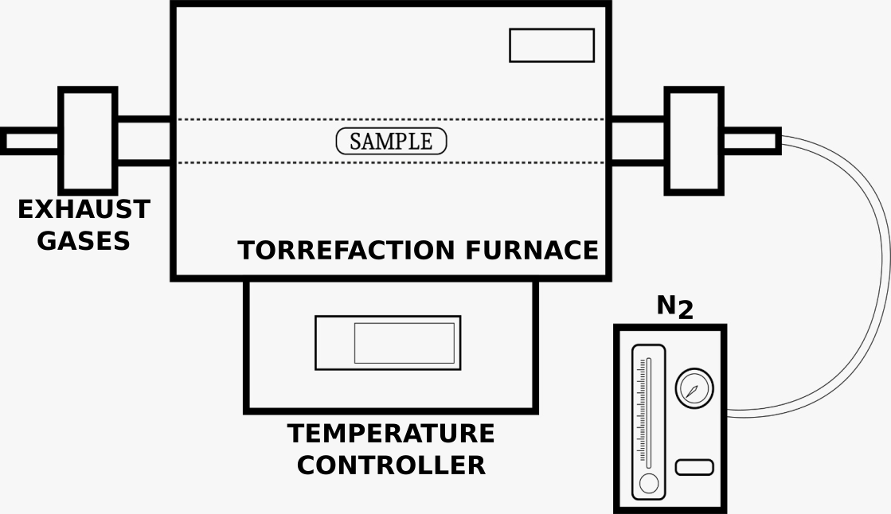

Figure 1. Torrefaction Experiment Setup

The samples were weighed before and after torrefaction to enable calculation of the mass yield (%) in all experiments according to Eq(1), where *mt* and *ma* are the sample weights before and after torrefaction, respectively.

|  |  |
| --- | --- |
|  | (1) |

The energy yield was calculated using Eq(2) and the torrefaction factor was obtained using Eq (3). The higher heating value (HHV) was determined experimentally by the combustion of 1 g of pellet in a bomb calorimeter (XRY-1A, China) under an oxygen atmosphere (30 bar) following UNE-EN ISO 18125:2018. These three performance indices are used to evaluate the torrefaction performance. Mass yield is used to evaluate the effect of torrefaction on mass loss. The energy yield is the chemical energy that remains in the torrefied pellet. The torrefaction factor is a measure of the severity of the torrefaction process in the pellets under various process conditions. It reflects both the energy yield as well as the energy density of the resulting biochar (zhang et al., 2018).

|  |  |
| --- | --- |
|  | (2) |

|  |  |
| --- | --- |
|  | (3) |

* + 1. Characterization of raw and torrefied pellets

The raw and torrefied pellets were characterized to study the effect of the torrefaction process on pellet quality. Carbon (C), hydrogen (H), and nitrogen (N) contents were determined using an elemental analyzer CHN 628LECO, and the oxygen (O) content was determined by subtracting the sum of all elements from 100 percent. Moisture content (MC) was determined as a loss in weight in a drying oven at 105°C, volatile matter (VM) was determined as a loss in weight at 950°C by 6 min, and ash content (AC) was determined as the residue after burning to constant weight at 550°C. This was carried out following the ISO 18134-3:2023, ISO 18123:2023, and ISO 21404: 2020 methods, the fixed carbon (FC) content was obtained by difference of ash and volatile matter contents. All of the analyses were carried out a minimum of three times.

* + 1. Thermogravimetric analysis

Thermogravimetric analysis (TG-DTG) and differential scanning calorimeter (DSC) of the raw pellets and torrified pellets were studied using a TGA analyzer (Netzsch STA 449F3). In each test, 10 ± 0.5 mg of powdered samples were heated from ambient temperature to 800 °C at heating rates 10 °C/min under an airflow of 50 ml/min. Thermogravimetric analysis was used to investigate the combustion performance and torrefaction influence in the samples.

* 1. Results and Discussion
     1. Effect of the torrefaction on pellets properties

Table 1 shows the mass yield, HHV, energy yield, and torrefaction factor of the raw and torrefied pellets. The HHV of the torrefied pellets is higher compared to the raw pellets and shows an increasing trend with increasing torrefaction temperature and residence time. The HHV of the pellets produced at 250 °C was between 33-35% higher than the original pellets, while those produced at 300 °C had an HHV between 39 and 40% higher. As the torrefaction temperature and time increase, the mass yield decreases because more chemical reactions occur, hemicellulose is the major contributor to dry mass loss during biomass torrefaction. (Manouchehrinejad and Mani, 2018).

Table 1: Effect torrefaction parameters

|  |  |  |  |  |
| --- | --- | --- | --- | --- |
| Sample | Mass yield (%) | HHV (MJ/kg) | Energy yield (%) | Torrefaction factor |
| Raw pellets | 100 | 17.7 | 100 | - |
| PT25030 | 55 | 26.4 | 82 | 1.50 |
| PT25060 | 50 | 27.9 | 79 | 1.59 |
| PT30030 | 40 | 29.3 | 67 | 1.67 |
| PT30060 | 39 | 29.4 | 65 | 1.67 |

The energy yield is reduced due to the decrease in the mass yield of the solid. The lowest mass yield was 38 wt% and it was obtained at the most severe torrefaction conditions 300°C and 60 min, this implies that approximately 62% of the raw pellet is thermally degraded from the torrefaction. Similar results were reported for previous studies of wood biomass. Iglesias Canabal et al.(2023) studied the torrefaction of pellets of debarked radiata pine, the results showed a highly significant effect of the torrefaction treatments on the energy properties, the mass yields were higher in the T300-40 and T300-60 samples (50.4% and 40.2%), the HHV reported were 26.5 and 26.2 MJ/kg respectively. The torrefaction factor increases with increasing torrefaction temperature, which is due to the high degree of mass loss resulting in the escape of volatile, condensable, and non-condensable gases (Mehdi., 2021).

* + 1. Elemental and Proximate Analysis

The proximate and elemental analyses are shown in Table 2. It was found that the volatile matter content decreased, while the fixed carbon and ash content of the torrefied pellets increased with an increase in torrefaction temperature and holding time. The moisture content of torrefied pellets is lower than that of raw pellets. This reduction in moisture content plays an important role in increasing energy efficiency, improving energy product quality, and reducing emissions in the thermochemical energy conversion process (Chen et al., 2015). The torrefaction process causes changes in the chemical composition of the raw pellets. During the devolatilization process, compounds containing hydroxyl groups present in the wood, especially hemicelluloses, are released as reaction products (gas and solid), reducing the hydrogen and oxygen content (Rousset et al.,2011). The increase in carbon content between 18-25% results in an increase in the energy content compared with the raw pellets. The decrease in hydrogen content with a simultaneous increase in carbon content can be considered as an indication of increased hydrophobicity in the samples (Ghiasi et al.,2014).

*Table 2: Proximate and elemental analysis*

|  |  |  |  |  |  |  |  |  |
| --- | --- | --- | --- | --- | --- | --- | --- | --- |
| Sample | MC (%) | VM(%) | Ash (%) | FC*\** (%) | C (%) | H (%) | N (%) | O*\**(%) |
| Raw pellets | 10 | 88.6 | 0.8 | 10.6 | 46.98 | 6.10 | 0.27 | 46.65 |
| PT25030 | 2.4 | 54.8 | 1.32 | 43.9 | 64.67 | 4.98 | 0.26 | 30.09 |
| PT25060 | 1.9 | 54.4 | 1.25 | 44.4 | 61.69 | 5.63 | 0.23 | 32.45 |
| PT30030 | 2.7 | 44.0 | 2.16 | 53.9 | 70.89 | 4.44 | 0.10 | 24.60 |
| PT30060 | 2.1 | 40.3 | 2.42 | 57.3 | 71.74 | 4.84 | 0.30 | 23.12 |

*\*by difference (All are in wt%, dry basis)*

* + 1. *Thermogravimetric analysis*

Thermogravimetric experiments TGA/DTG (Figure 2) and DSC (Figure 3) were used to study the combustion behavior of the raw and torrefied pellets. Figure 2 shows that the combustion takes place in two stages, for the raw pellets the first stage occurs between 200 and 350°C, this represents the devolatilization and combustion of light volatiles and the decomposition of hemicellulose (Bridgeman et al., 2008). The second stage above 350°C represents the char combustion (Riatz et al., 2023). The first peak observed in DTG curve of the raw pellet is slightly observed in the pellet torrefied at temperatures of 250 °C, but is not present above PT30060 curve (300 °C,60 min). Above 300°C, the mass loss curves were more pronounced for the torrefied samples than for the non-torrefied samples.

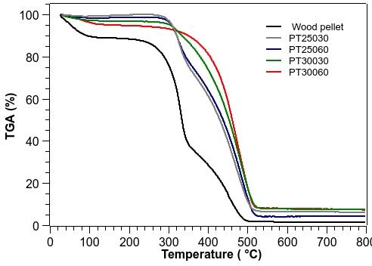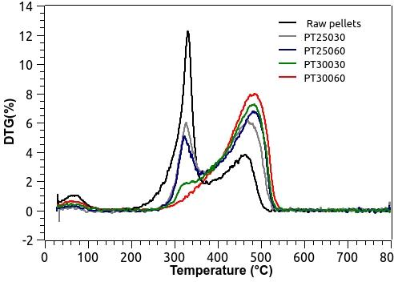

Figure 2: Thermogravimetric analyses curves of wood pellets and torrefied pellets a)TGA; b) DTG

In the Differential Scanning Calorimeter (DSC) Figure 3, two different exothermic reaction regions were observed. In the first region, the peak presence of the raw pellets is more pronounced. It was observed that with an increase in torrefaction temperature and holding time, the peak presence decreased. The second region shows that the peaks increase with increasing torrefaction temperature. The first region is due to the combustion of light volatiles and the second region represents the combustion of fixed carbon (Kok and Özgür, 2013).

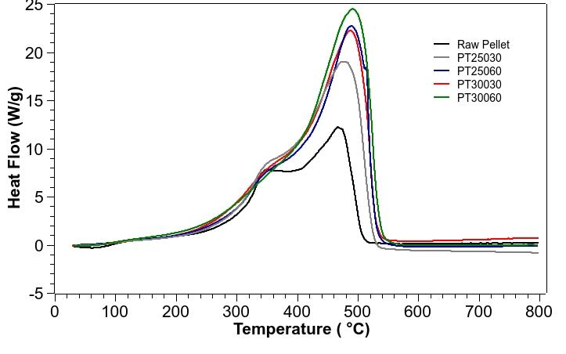

*Figure 3: DSC curves of raw pellets and torrefied pellets*

Table 3 shows the reaction regions observed in the DSC, ignition temperature (Ti), and Burnout temperature (Tb). The raw pellets are the easiest to ignite of the refined samples. This is because they have the highest VM content. The ignition temperature is the minimum temperature at which a fuel will spontaneously ignite; this is highly relevant to its safety in storage and delivery when used as a fuel in the industry (Lu et al.,2015). The burnout temperature of the PT30060 is higher than the other samples, this refers to the temperature at which combustion is complete. In addition, both ignition and burnout temperatures are key parameters for evaluating fuel selection, consumption, and combustor design (Lu et al.,2015).

Table 3: Proximate and elemental analysis

|  |  |  |  |  |
| --- | --- | --- | --- | --- |
| Samples | Region 1 | Region 2 | Ti (°C) | Tb (°C) |
| Raw pellets | 163-381 | 405-529 | 163 | 529 |
| PT25030 | 200-377 | 394-549 | 200 | 549 |
| PT25060 | 210-370 | 425-550 | 210 | 550 |
| PT30030 | 215-370 | 413-556 | 215 | 556 |
| PT30060 | 233-377 | 412-563 | 233 | 563 |

The heat liberated during biomass combustion is based on the area under the DSC curve (Kok and Özgür, 2013). According to Figure 3, the second region shows that the heat liberated from raw pellets is lower than that from torrified pellets. Combustion of torrefied pellets produces higher heat and reactions, and these increase at higher torrefaction temperatures. This is related to carbon content and HHV, which increase as torrefaction occurs (Tables 1 and 2). The results obtained are consistent with the DTA studies of Bridgeman et al. (2018), in which they show that the combustion of torrefied biomass produces higher reaction heat during combustion and this increases for fuels produced at higher torrefaction temperatures. The lower values for raw biomass are attributed to the higher moisture content of these fuels.

* 1. Conclusions

ITorrefaction of *Pinus Elliottii* wood pellets was studied to determine the effect of torrefaction processes on the energetic properties of the pellets. Temperature had a significant effect on the HHV of the pellets. The HHV of pellets produced at 250 °C was between 33-35% higher than the original pellets, while those produced at 300°C had an HHV between 39 and 40% higher. Time had no significant effect compared to temperature. The raw pellet became highly carbonaceous with the torrefaction process, presenting a carbon content of 64.7% at 250 °C and 71.44% at 350 °C, which is between 18-25% higher than the raw pellet. Combustion behavior showed differences between torrefied pellets and raw pellets. Torrefied pellets produced higher heat of combustion during char burnout due to the higher fixed carbon content. This study shows that it is possible to combine torrefaction and densification processes to improve the physical and energetic properties of raw pellets to produce a solid fuel that can be used as a tradable commodity to potentially replace fossil fuels. Future research should delve into optimizing the torrefaction process parameters for different biomass types and evaluating the long-term storage stability and transport logistics of torrefied biomass to further understand its potential as a global energy commodity.

Nomenclature

DSC – Differential scanning calorimeter

DTG – derivative thermogravimetric

FC – fixed carbon

HHV – higher heating value (MJ/kg)

ma – mass after torrefaction (g)

mt – mass before torrefaction (g)

MC – moisture content

TGA – Thermogravimetric analyses

Ti–ignition temperature

Tb– Burnout temperature

VM –volatile matter

wb – wet basis (%)

Acknowledgments

The authors sincerely thank the Uruguayan company "Delta global" for the pellet samples. They also thank the "Instituto Nacional de Investigación Agropecuaria (INIA) Uruguay" for performing the CHN analysis.

References

BEN, 2022, National Energy Balance, Ministerio de Industria, minería y energía <//ben.miem.gub.uy/balance.php> accessed 10.01.2024.

Bridgeman, T.G., Jones, J.M., Shield, I., Williams, P.T., 2008. Torrefaction of reed canary grass, wheat straw and willow to enhance solid fuel qualities and combustion properties. Fuel 87, 844–856.

Chen, W.-H., Peng, J., Bi, X.T., 2015. A state-of-the-art review of biomass torrefaction, densification and applications. Renewable and Sustainable Energy Reviews 44, 847–866.

Ghiasi, B., Kumar, L., Furubayashi, T., Lim, C.J., Bi, X., Kim, C.S., Sokhansanj, S., 2014. Densified biocoal from woodchips: Is it better to do torrefaction before or after densification? Applied Energy 134, 133–142.

Iglesias Canabal, A., Proupín Castiñeiras, J., Rodríguez Añón, J.A., Eimil Fraga, C., Rodríguez Soalleiro, R., 2023. Predicting the energy properties of torrefied debarked pine pellets from torrefaction temperature and residence time. Renewable Energy 218, 119346.

Kok, M.V., Özgür, E., 2013. Thermal analysis and kinetics of biomass samples. Fuel Processing Technology 106, 739–743.

Kumar, L., Koukoulas, A.A., Mani, S., Satyavolu, J., 2017. Integrating Torrefaction in the Wood Pellet Industry: A Critical Review. Energy Fuels 31, 37–54.

Manouchehrinejad, M., Mani, S., 2018. Torrefaction after pelletization (TAP): Analysis of torrefied pellet quality and co-products. Biomass andBioenergy 118, 93–104.

Mauro, C., Rentizelas, A.A., Chinese, D., 2018. International vs. domestic bioenergy supply chains for co-firing plants: The role of pre-treatment technologies. Renewable Energy 119, 712–730.

Mehdi, R., Raza, N., Naqvi, S.R., Khoja, A.H., Mehran, M.T., Farooq, M., Tran, K.-Q., 2021. A comparative assessment of solid fuel pellets production from torrefied agro-residues and their blends. Journal of Analytical and Applied Pyrolysis 156, 105125.

Lu, J.-J., Chen, W.-H., 2015. Investigation on the ignition and burnout temperatures of bamboo and sugarcane bagasse by thermogravimetric analysis. Applied Energy 160, 49–57.

Rentizelas, A.A., Tolis, A.J., Tatsiopoulos, I.P., 2009. Logistics issues of biomass: The storage problem and the multi-biomass supply chain.Renewable and Sustainable Energy Reviews 13, 887–894.

Riaz, S., Oluwoye, I., Al-Abdeli, Y.M., 2023. Torrefaction of densified biomass using flue gases in a fixed bed combustor. Applied Thermal Engineering 233, 121157.

Rousset, P., Aguiar, C., Labbé, N., Commandré, J.-M., 2011. Enhancing the combustible properties of bamboo by torrefaction. Bioresource Technology 102, 8225–8231.

San Miguel, G., Sánchez, F., Pérez, A., Velasco, L., 2022. One-step torrefaction and densification of woody and herbaceous biomass feedstocks. Renewable Energy 195, 825–840.

Tursi, A., 2019. A review on biomass: importance, chemistry, classification, and conversion. Biofuel Res. J. 6, 962–979.

Zhang, C., Ho, S.-H., Chen, W.-H., Xie, Y., Liu, Z., Chang, J.-S., 2018. Torrefaction performance and energy usage of biomass wastes and their correlations with torrefaction severity index. Applied Energy 220, 598–604.